_____________________________________________________________________________

create table tb_cliente(

cli_id integer,

cli_nome nvarchar(20),

cli_fone nvarchar(10),

primary key(cli_id)

);

create table tb_apartamento(

apto_id integer,

apto_descricao nvarchar(80),

apto_status nvarchar(15),

primary key(apto_id)

);

create table tb_check_in(

cli_id integer,

apto_id integer,

dt_entrada date,

vl_diaria double,

foreign key(cli_id) references tb_cliente(cli_id),

foreign key(apto_id) references tb_apartamento(apto_id)

);

create table tb_check_out(

cli_id integer,

apto_id integer,

dt_saida date,

foreign key (cli_id) references tb_cliente(cli_id),

foreign key (apto_id) references tb_apartamento(apto_id)

);

create table tb_hospedagem(

cli_id integer,

dt_entrada date,

dt_saida date,

vl_diaria double,

qtde_dias integer,

vl_pagar double,

foreign key(cli_id) references tb_cliente(cli_id)

);

_____________________________________________________________________________

insert into tb_cliente values(1,'Pedro','99675-8976');

insert into tb_cliente values(2,'André','99064-0009');

insert into tb_cliente values(3,'Marta','99094-5566');

insert into tb_cliente values(4,'Rute','99675-7645');

insert into tb_cliente values(5,'Carla','98734-3297');

insert into tb_cliente values(6,'Joaquim','97526-0354');

insert into tb_apartamento values(134, 'TV, Ar-condicionado, frigobar','Livre');

insert into tb_apartamento values(135, 'TV, Ar-condicionado, frigobar','Livre');

insert into tb_apartamento values(136, 'TV, ventilador, frigobar','Livre');

insert into tb_apartamento values(137, 'TV, ventilador, frigobar','Livre');

insert into tb_apartamento values(138, 'TV, ventilador, frigobar, cofre','Livre');

insert into tb_apartamento values(139, 'TV, ventilador, frigobar, cofre','Livre');

_____________________________________________________________________________

Procedures and Triggers

DELIMITER $$

CREATE TRIGGER check_in

AFTER INSERT ON tb_check_in

FOR EACH ROW

BEGIN

INSERT INTO tb_hospedagem VALUES(new.cli_id, new.dt_entrada, null, new.vl_diaria, null, null);

END $$

DELIMITER ;

DELIMITER $$

CREATE TRIGGER check_out

AFTER INSERT ON tb_check_out

FOR EACH ROW

BEGIN

UPDATE tb_hospedagem SET dt_saida = now() where cli_id in (select cli_id from tb_check_out);

END $$

DELIMITER ;

DELIMITER $$

CREATE TRIGGER qtde_dias

AFTER INSERT ON tb_check_out

FOR EACH ROW

BEGIN

UPDATE tb_hospedagem SET qtde_dias= datediff(dt_saida, dt_entrada);

END$$

DELIMITER ;

DELIMITER $$

CREATE TRIGGER status_entrada

AFTER INSERT ON tb_check_in

FOR EACH ROW

BEGIN

UPDATE tb_apartamento SET apto_status ='Ocupado' where apto_id in (select apto_id from tb_check_in);

END$$

DELIMITER ;

DELIMITER $$

CREATE TRIGGER status_saida

AFTER INSERT ON tb_check_out

FOR EACH ROW

BEGIN

UPDATE tb_apartamento set apto_status ='Livre' where apto_id in (select apto_id from tb_check_out);

END$$

DELIMITER ;

Resposta 04.

delimiter $$

CREATE procedure pagamento()

begin

update tb_hospedagem

set vl_pagar = vl_diaria * qtde_dias

where dt_saida is not null;

end$$

Resposta 05.

select * from tb_apartamento; 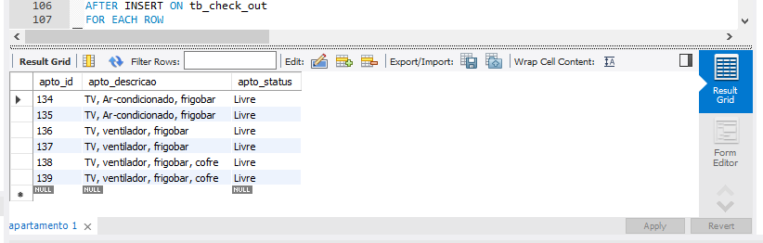

Resposta 06.

insert into tb_check_in values(1, 135, '2019/09/01', 170.00);

insert into tb_check_in values(2, 134, '2019/09/02', 160.00);

insert into tb_check_in values(3, 138, '2019/09/02', 200.00);

insert into tb_check_in values(4, 139, '2019/09/03', 180.00);

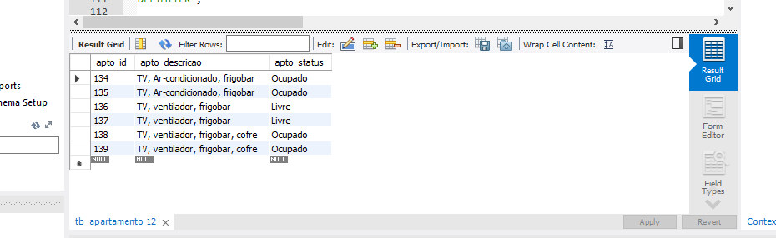

select *from tb_check_in;

SET SQL_SAFE_UPDATES = 0;

Resposta 07.

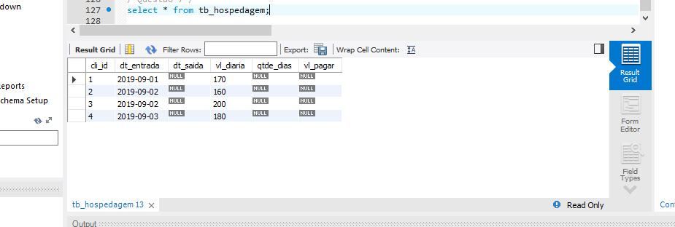

select * from tb_hospedagem;

Resposta 08.

insert into tb_check_out values(1, 135, now());

insert into tb_check_out values(2, 134, now());

insert into tb_check_out values(4, 139, now());

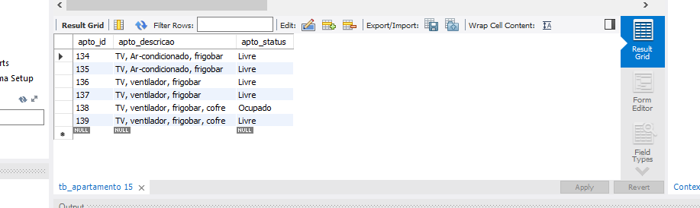

select * from tb_check_out;

select * from tb_apartamento;

Resposta 09.

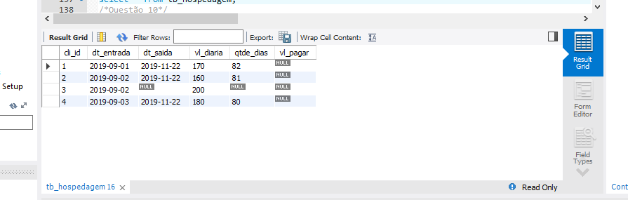

select * from tb_hospedagem;

Resposta 10.

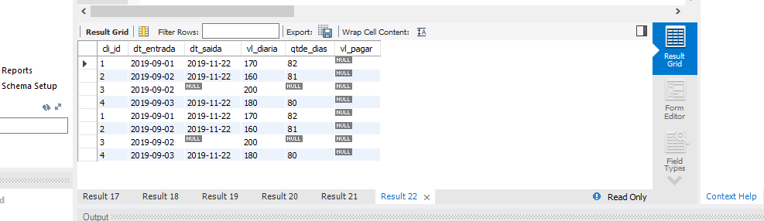

call pagamento;

Reposta 11.

select * from tb_cliente;

select * from tb_apartamento;

select * from tb_check_in;

select * from tb_check_out;

select * from tb_hospedagem; 